

This smart photoelectric smoke sensor, with ultra-low-power ZigBee wireless network technology design. It is an warning device, cannot sense gas, heat, or flame, cannot prevent or put out fire. Real-time detecting the presence of smoke, detection of visible particles(smoldering fire) faster than ionization smoke alarms. Red LED flashes rapidly and detectors sound alarm once detecting smoke fire danger, it can alert you and your family

timely. Smoke alarms should be installed in all rooms, living room, storage areas and basements that fire may happen.



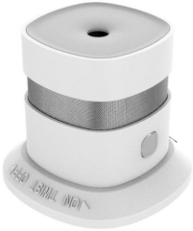

***Premium Add-on device for your home***

**Smart Smoke Sensor**

* **Standard ZigBee protocol, good compatibility;**
* **Super low power consumption design, battery lifespan up to 36 months;**
* **Support remotely hush function through APP;**
* **Low power alert and report function;**
* **Easy taking out battery and replacing battery;**
* **Free tool installation, stick and play;**
* **Smart and fasion design, with appearance design patent;**

***Features***

Specification

* Model Number: HS1SA-TY
* Working Voltage: DC3V
* Battery Type: CR123A lithium battery
* Battery Life: 3 years
* Standby Current: <12uA
* Alarm Current: ≤60mA
* Alarm Voice Volume: ≥85dB/3m
* Networking Way: ZigBee 2.4GHz
* Wireless Distance: ≤70m (open environment)
* Anti-RF Interference：80MHz — 1GHz 10V/m
* Working Temperature:-10℃ ～ +50℃
* Working Humidity：≤95%RH
* Product Size：60x60x49.2mm
* Gross Weight: 85g